**Snapshot:**

Snapshots are a point-in-time copy of your data, and can be used to enable disaster recovery, migrate data across regions and accounts, and **improve backup compliance.**

**[] EC2 dashboard**

**[] select snapshots and select create snapshots**

**[] select instance**

**[] in instance ID select instances**

**[] create snapshots**

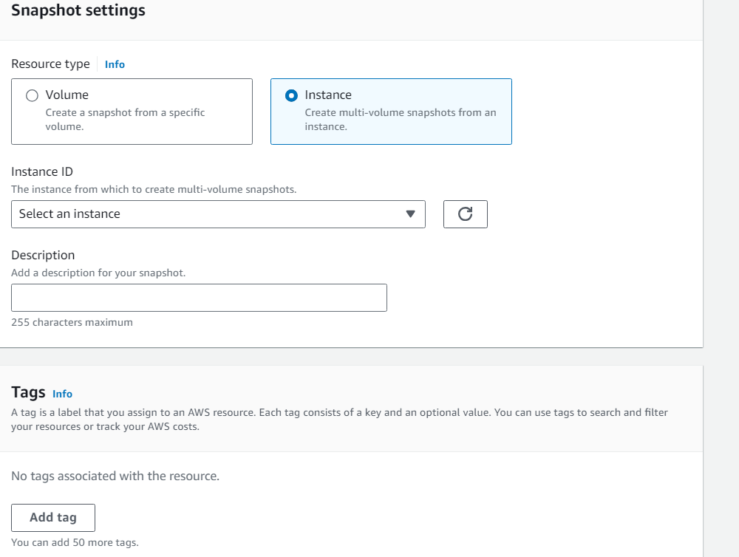

**[] Select owned by me**

**[] wait till it showing active**

**[] select active**

**[] select create image from snapshot**

**[] image name and create image**

**[] in EC2 dashboard select AMIs**

**[] select owned by me**

**[] go to instance**

[] **lunch instance** and in **Application and OS Images (Amazon Machine Image) select** **my AMIs** and **select AMI what we created**

[] after follow same

**Automatic taking snapshot:**

**[] Go to EC2**

**[] select lifecycle manager**

**[] select EBS snapshot policy**

**[] in target resource tags give key and value this tag used in tag of instances**

**[] in policy status, select enable and next**

**[] in schedule details. Schedule name, frequency, every, starting at and next**

**[] then create policy**

**[] after triggering or it take some time**

**[] go to snapshots**

**[] select owned by me**

**[] after some time, snapshot is created**